**Year 10 Physics EXAM Name: ________________**

**Teacher:**

**Multiple Choice Answer Sheet Total = /43 marks**

1. A B C D 11. A B C D

2. A B C D 12. A B C D

3. A B C D 13. A B C D

4. A B C D 14. A B C D

5. A B C D 15. A B C D

6. A B C D 16. A B C D

7. A B C D 17. A B C D

8. A B C D 18. A B C D

9. A B C D

10. A B C D

[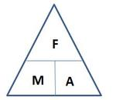](http://www.google.com.au/url?sa=i&rct=j&q=force+mass+acceleration+triangle&source=images&cd=&cad=rja&docid=O6V53PkQA165NM&tbnid=vhNrW-efYEJTlM:&ved=0CAUQjRw&url=http://jdevlin.pottsgrove.wikispaces.net/Physics+Tasks+2012&ei=z6IRUqS2NYyXkgXUoIDwCg&psig=AFQjCNGaoVG_TT9V-bDQMdMZk8qwyYJa6Q&ust=1376973888721903)**Formula you may need**

[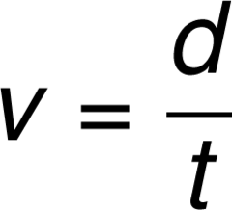](https://www.google.com.au/url?sa=i&rct=j&q=&esrc=s&source=images&cd=&cad=rja&uact=8&ved=0ahUKEwjisbeVs6jJAhXG6KYKHbljAFcQjRwIBw&url=https://quizlet.com/23637140/mcat-physics-formulas-flash-cards/&psig=AFQjCNF73SyJ1cmnV3VEsXKA7wno-uXSmA&ust=1448431824822180)

**F= m x a**

[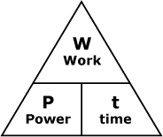](http://www.google.com.au/url?sa=i&rct=j&q=power+woek+time+triangle&source=images&cd=&cad=rja&docid=smEqr3_xk2x1UM&tbnid=FClwhBw-QCE5sM:&ved=0CAUQjRw&url=http://courses.learn60.ca/mod/book/tool/print/index.php?id=18292&ei=DKQRUvmSBoH-kgXw5oDYCg&psig=AFQjCNGFckk2PLfTo6F-_nHw8K9GjonyFA&ust=1376974213287723)[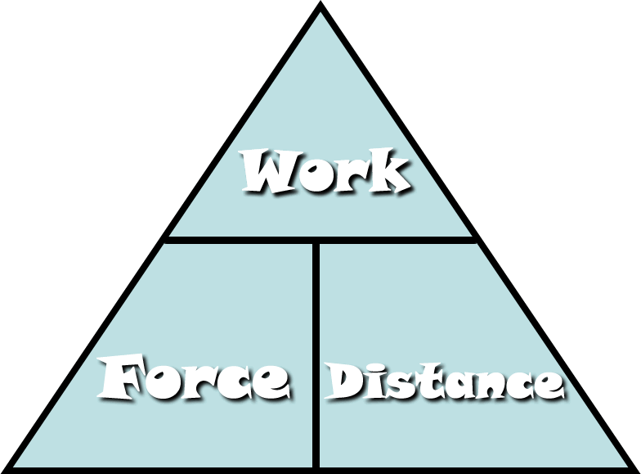](http://www.google.com.au/url?sa=i&rct=j&q=work+force+distance+triangle&source=images&cd=&cad=rja&docid=Fi7mPF8FJi6IOM&tbnid=aV4S5kcpYVNcwM:&ved=0CAUQjRw&url=http://fhm.fhsd.k12.mo.us/jhughes/Hughes/Units/Work&MachinesContent.htm&ei=0aMRUtjOGYyXkgXUoIDwCg&psig=AFQjCNG-nrT1bFGRuWdPLe1VAUwfrjBuYQ&ust=1376974154992588)

**W = F x d P = W / t**

Ek = ½ m x v2

[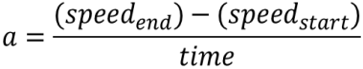](http://www.google.com.au/url?sa=i&rct=j&q=formula+acceleration&source=images&cd=&docid=n1BQvXMu3V1gnM&tbnid=tyy5e7co4fxZgM:&ved=0CAUQjRw&url=http://www.etorgerson.net/WebPages/ScienceUnits/A04_Acceleration.html&ei=ivH1UbrJMIiPkwW0pYD4Bg&psig=AFQjCNGKaO8mY3zS4cauOZdzzpsrQErjaw&ust=1375159034805046)

**Et = Ek + Ep**

**a = v – u**

[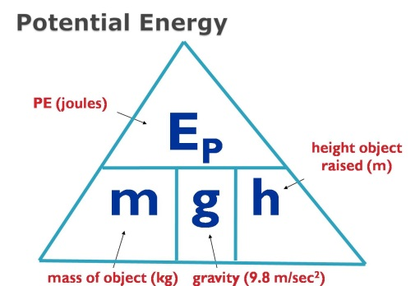](http://www.google.com.au/url?sa=i&rct=j&q=potential+energy+formula&source=images&cd=&cad=rja&docid=2H-GFaF9wBc-AM&tbnid=AD-1C8B0bBkYWM:&ved=0CAUQjRw&url=https://www.allthink.com/v/potentialenergy&ei=hqQRUs2qJsiNkAWSp4DICQ&psig=AFQjCNFHln3I7-BEBHAERUecIisFWqbMGw&ust=1376974319301500) **t**

[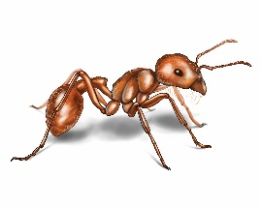](http://www.google.com.au/url?sa=i&rct=j&q=ant&source=images&cd=&cad=rja&docid=xnY1A86yla2paM&tbnid=RzulS6ugMKx4fM:&ved=0CAUQjRw&url=http://www.orkin.com/ants/harvester-ant/&ei=dZs7UrXWFNDDkAWDrIHoDA&psig=AFQjCNH_SG2m2KFbnhWkRaDTwREnye2S-g&ust=1379724529024052)**1** What distance would an ant, crawling at a speed of 2 centimetres per second, cover in an hour?

A 120 cm

B 7200cm

C 1200m

D 7200m

[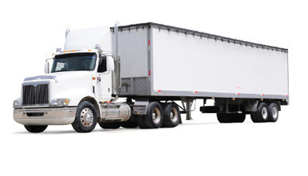](http://www.google.com.au/url?sa=i&rct=j&q=truck&source=images&cd=&cad=rja&docid=GlxTeazisYpVTM&tbnid=cIb0qlzGCFXRvM:&ved=0CAUQjRw&url=http://www.manheim.com.au/trucks-machinery&ei=5Zs7UpzUJsfXkAX_vYC4CA&psig=AFQjCNEoBMmdlbny4o7ldQaAxL4nTTAhMw&ust=1379724629270576)

**2** A truck travels at a speed of 18 m/s. This is equivalent to a speed of:

A 5 km/h

B 64.8 km/h

C 64 800 km/h

D 54 km/h

[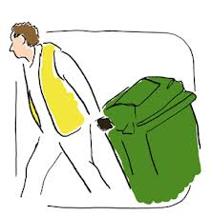](http://www.google.com.au/url?sa=i&rct=j&q=put+out+wheely+bin&source=images&cd=&cad=rja&docid=29pzR1WcQ3u_eM&tbnid=3Co3y0nBE_mw2M:&ved=0CAUQjRw&url=http://www.oxfordshire.gov.uk/cms/content/rubbish-and-recycling-oxfordshire&ei=g9A7UsKpCIKIkwWw6YH4Dg&psig=AFQjCNGHJ3ZxsU6cRHbs3zRqdJid1aroRw&ust=1379738041806358)**3** Chris applies a 90 N to a 65 kg bin. The bin will accelerate at:

A 0.138 m/s2

B 1.38 m/s2

C 5850 m/s2

D 58.5 m/s2

**4** Power is the rate at which energy is supplied. What power is needed to supply 6000 J to lift a child up a vertical cliff face in 5 seconds?

A 1200 W

B 120 W

C 300 000 W

D 30 000 W

**5**

The motion of three objects, X, Y and Z, is captured using the three ticker tapes shown below.

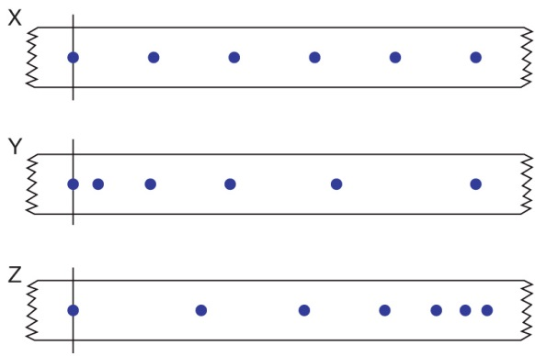

Select the response that best describes the motion of the objects X, Y and Z as described by these sections of ticker tape.

A Object X starts off more slowly than object Y.

B Object X gradually speeds up its motion.

C Object Z starts off with the greatest speed of the three objects.

D Object Y gradually slows its motion

**6** Choose the correct definition for ‘potential energy’.

A Energy found in moving light energy.

B Energy found in moving sound waves

C Energy that is stored.

D Any energy of movement.

**7** Choose the correct definition for ‘kinetic energy’.

A Energy that is stored in chemicals.

B Energy that is stored in a stretched object.

C The energy of a moving object.

D The energy stored in a litre of fuel.

**8** An aircraft is flying in a straight line at constant altitude and at a constant speed. What can be said about the forces on the aircraft?

A The forces are unbalanced.

B The forces are balanced.

C The forces are compression forces.

D The aircraft is accelerating.

**9** Inertia can be define as:

A the amount of matter in an object

B the force of gravity on an object

C the tendency of an object to resist change in its motion

D when a force makes something move

**10** Which of the following is best explained by Newton’s Third law?

A Unbelted passengers will be thrown forward when a car stops suddenly.

B A gun recoils when a shot is fired.

C The acceleration of an object when a force is applied depends on the mass of the object.

D The weight of an object varies from planet to planet.

**11** Which of the following has kinetic energy?

A A bike parked on a hill.

B A child running.

C A stretched balloon.

D A bumblebee hovering in the same spot.

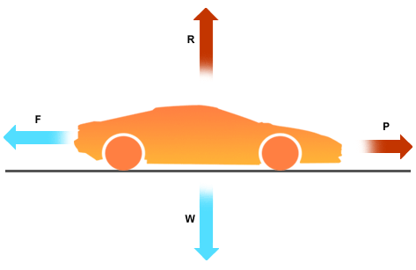

**12** Which of the following is **correct** about the movement of the car?

600 N

100 N

A The car is still

B The car is at a constant speed

C The car is accelerating forward

D The car is reversing

**13** Shania drops a ball that weighs 3 kg from a height of 4m.

Calculate the ball’s Potential energy when it is released

A 22.5 J

B 11.7 J

C 225 J

D 117.6 J

**14** The Total Energy E T is 2558 J if a falling object has Potential Energy of 198 J Calculate the Kinetic Energy

A 2360 J

B 2756 J

C 0 J

D 198 J

**15** Leslie ran a second race but is unable to finish after spraining an ankle and 120 m east of the finish line. Given that the distance to be run in the race was 1000 m, and that the finish line was where the race started, the displacement of Leslie would be:

A 120 m east

B 120 m west

C 880 m east

D 880 m west

**16** Which of the following is **incorrect** about the speed time graph below?

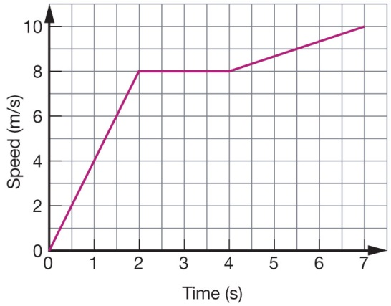

A The speed after 3 seconds is 8m/s

B The distance travelled after 2 seconds is 12m

C The distance travelled after 3 seconds is 8m

D The speed after 7 seconds is 10m/s

**17** Which of the following explains Newtons First Law?

A The motion of an object will not change if all the forces acting on it are balanced

B For every force there is an equal and opposite force

C An object will accelerate in the direction of an unbalanced force

D F = m x a

**18** Which of the following is **not** an example of potential energy?

A A bike parked on a hill.

B A skateboard moving down a hill

C A stretched balloon.

D A rock on the edge of a cliff

**Short Answer: Name: _________________**

**Answer in the spaces provided 25 marks**

**1** **Classify the following as True or False:**  (6)

a A motorbike is accelerating away from traffic lights : this is INERTIA True / False

b Work is the ability to exert force over a distance True / False

c Acceleration depends on mass and distance True / False

d Velocity is a measure of Power True / False

e The reason a ball bounces is because “energy is not

lost or created but is transformed” True / False

f Displacement has a measurement and a direction True / False

**2.** State Newton’s Third Law of Motion (1)

______________________________________________________________________________________________________________________________________________________________________________________________________________________________________________________

[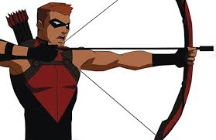](http://www.google.com.au/imgres?imgurl=http://www.writeups.org/img/inset/Red_Arrow_YJTV_h2.jpg&imgrefurl=http://www.writeups.org/fiche.php?id%3D5242&h=389&w=600&tbnid=8BHuG_mgtKVSDM:&docid=j9yOZ540PEWiyM&hl=en&ei=RwxUVpKSO6bFmAX0zKToDw&tbm=isch&ved=0ahUKEwjS0ZTDv6jJAhWmIqYKHXQmCf0QMwh9KFowWg)

Describe what happens to the arrow and bow which shows Newton’s Third Law (2)

________________________________________________________________________________________________________________________________________________________________________________________________________________________________________________________________________________________________________________________________________

**3.**  A student performs an experiment with some coins and a piece of paper

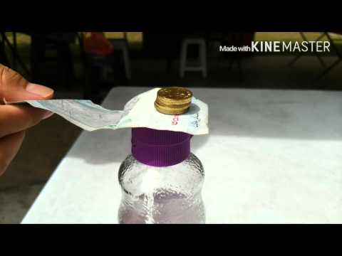

The paper is pulled quickly away – describe what happens to the coins. (2)

________________________________________________________________________________________________________________________________________________________________________________________________________________________________________________________________________________________________________________________________________

Which of Newton’s Laws explains this concept: (1)

____________________________________________________________________________________________________________________________________________________________________

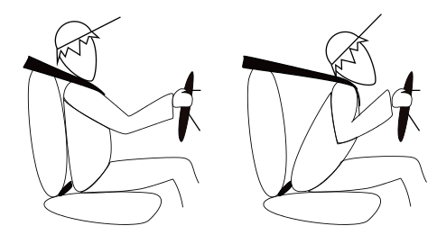

**4** Describe what happens in the picture above when car brakes suddenly: (2)

______________________________________________________________________________________________________________________________________________________________________________________________________________________________________________________

__________________________________________________________________________________

**5** Calculate the WORK done : (2)

Kelly uses a force of 160 N to moves a BOX a distance of 5 metres

**6** A ball is dropping from 2.5 m the Kinetic energy is 2655 J the Potential energy is 3411 J.

Calculate the total energy (2)

**7** Fill in the following table (3)

|  |  |
| --- | --- |
|  | **Units** |
| Force |  |
| Energy |  |
| Work |  |
| Speed |  |
| Acceleration |  |
| Kinetic Energy |  |

1. Adam runs a marathon, a 39 km long distance race. It takes him 4 hours.

What was his average velocity (speed)? (2)

1. What happens in each of these unbalanced forces? (2)

*Craig*  650N Andrew 200N



